Driven to Quickly Generate Energy Cost Savings by Negotiating Lowest Possible Utility Rates & Maximizing Efficiency of Mechanical & Electrical Equipment

ENERGY ARCHITECTS is a research and engineering company that since 1981 has helped clients develop unique and innovative strategies to purchase utilities and maximize the efficiency of their energy dollars. Our team of engineers and analysts specialize in negotiating rate discounts for large users of electricity and natural gas in both regulated and deregulated areas of the country. Our efforts have saved our clients over $160 million dollars during the past 30 years.
Our rate experts have saved qualifying clients as much as 20% to 40% on their electric & gas bills.

OUR EXPERTISE CAN ALSO DELIVER RESULTS THAT MAXIMIZE ENERGY COST SAVINGS
- Bringing “Energy Answers” to all types of facilities.
- Employing high tech solutions that can promote energy cost savings on mechanical and electrical equipment
- Through our ConServ Energy Group we are experts in state of the art “MagLev” chillers, saving 50% on energy
- Heat recovery is also a ConServ Energy specialty capturing waste heat from boilers and other processes
- Variable frequency drives can save energy by the power of 3 on pumps, fans, and other motor applications
For our rate study there is absolutely no cost or risk to you - We get paid ONLY if we save you money and have secured and documented your savings

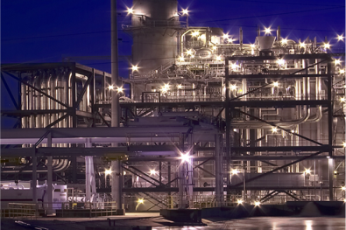

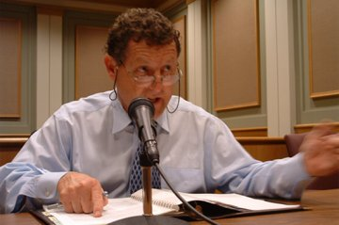

In his representation of clients before regulatory agencies across the country, Paul Holland has been successful 100% of the time.
QUALIFYING CLIENTS –Our clients around the U.S. are typically large industrial or commercial users of electricity and or natural gas with minimum annual total utility cost of $500,000 for electricity or $250,000 for natural gas.
It's quick and easy - Very little of your time is required. Just authorize us to have talks with your utilities. We will try to develop innovative rates and purchasing strategies with them and then bring the savings plan back to you for your final approval. animplementation.

The value we bring to energy cost savings requires extensive experience that is rarely, if ever, found in even the best companies.

Energy Architects
5123 Virginia Way, Suite C-21
Brentwood, TN 37027
Office: (615) 221-9022 • Fax: (615) 221-9672
Paul W. Holland, P.E.
(E-mail) pholland@energyarchitects.com

Additional information available at:
http://www.energyarchitects.com

